Tech Lead with specializing in backend development. Experienced with all stages of the development cycle for dynamic web projects. Strong background in project management and customer relation . Professional and trustworthy Material Handler with 6.7 years of experience in handling CRM, ERP , Job Portal ,Healthcare and Banking Domains | 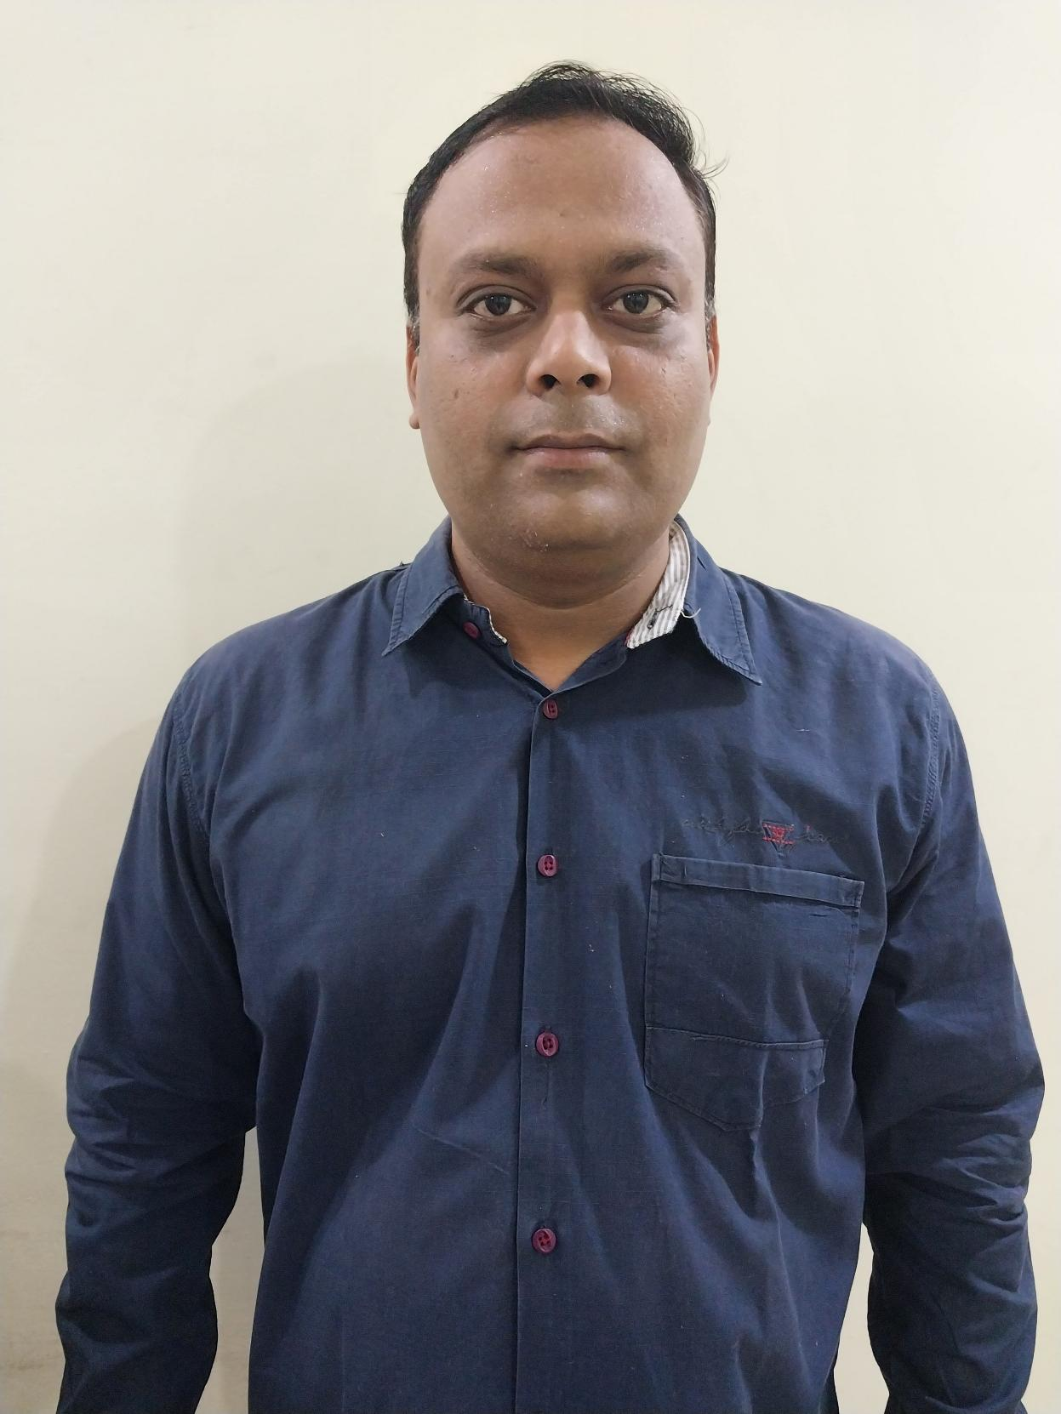
- Total Year Of Experience 8.9
- 5.8 Years of experience in Python Stack
Detailed Summary

Experience
Duration | Organization | Role | Domain
1.8 Year | KPIT Pune | Tech Lead | Automated Testing Infrastructure
1.8 years | Torinit Consulting Services pvt. ltd | Senior Software Engineer | ERP , Banking
1.8 years | Flying Penguins | Python Developer | SAAS Based Application
3 Months | Xlix Infotech | Operation Manager + Senior Developer | CRM
2.2 years | Ubiquity Techs | Senior Software Engineer | Jobportal , ERP ,CRM
4 months | Sanisoft | Jr.web Developer | Shopping website
1 years | Tantransh Solution | Web Developer | HealthCare HMS

Organization | KPIT ,Pune
Client | General Motor | Project | Optimus
Period | July 2023-Aug 2024 | Duration | 1.2 years
Role | Technical Lead
Environment | PowerBI,Python,Java,Jenkins,Azure
Project Description | GM has conceived a high-level vision for Continuous Integration & Continuous Deployment (CI/CD) automated testing infrastructure focused on building and testing MCU/Aggregator controller software intended for Software Defined Vehicle (SDV) applications. GM targets to define & implement key pipelines to carry out the automation and implementation of dashboards to communicate the health of the system as well as statistics associated with the assets being produced. The main objective of the CICD framework is to develop a platform to standardize CI/CD process across Components, Pods & Controllers and to provide comprehensive view of projects health based on predefined KPIs through Quality Dashboards.
Contribution | - 1.Developed Adapter Code: Successfully wrote adapter code to get data from pipeline and dump it into DB for all Jenkins pipelines  - Collaboration on Jenkins Integration: Worked closely with Jenkins Team  - Wrote Python script retrieves data from the VCMU controller API , Optimus Database and Optimus console logs  - Wrote Python script to processes the data and generates an Excel sheet  - Created Improved and Optimized Code For Project  - Offshore Team Management: Effectively handled the offshore team, providing guidance and monitoring progress through Jira and KAP, ensuring alignment with project goals.  - System Demo Presentation: Presented the work completed for TFRP to the GM team at the System Demo meeting, providing insights into the progress and achievements.  - Actively Take Part in Project Discussion ,Requirement Gathering ,Client Call

Organization | KPIT ,Pune
Client | General Motor | Project | TFRP
Period | Sep 2024 to Feb 2025 | Duration | 0.6 months
Role | Technical Lead
Environment | Azure, Python ,PowerBI ,Jenkins Pipeline
Project Description | GM has conceived a high-level vision for TFRP automated testing infrastructure focused on building and testing software intended for Software Defined Vehicle (SDV) applications.
Contribution | - Developed Adapter Code: Successfully wrote adapter code to get data from pipeline and dump it into DB for all Jenkins pipelines  - Collaboration on Jenkins Integration: Worked closely with Jenkins Team  - Created Improved and Optimized Code For Project  - Offshore Team Management: Effectively handled the offshore team, providing guidance and monitoring progress through Jira and KAP, ensuring alignment with project goals.  - System Demo Presentation: Presented the work completed for TFRP to the GM team at the System Demo meeting, providing insights into the progress and achievements.  - Actively Take Part in Project Discussion ,Requirement Gathering ,Client Call

Organization | Torinit Consulting Services pvt. Ltd , Nagpur
Client | Rogers Bank | Project | Rogers Bank
Period | July 2022-June 2023 | Duration | 1 years
Role | Senior Sofware Engineer
Environment | AWS,Python
Project Description | Rogers Bank has been delivering innovative credit cards to Canadians since 2013. Rogers Bank’s products and services are designed to maximize value for Rogers customers and provide ultimate flexibility, helping customers turn their everyday spending into infinite possibilities
Contribution | Perform End-to-End Development  - Worked closely with the product team on the scope of future projects and innovations  - Created Improved and Optimized Api For Project  - Actively Take Part in Project Discussion ,requirement gathering ,Client call

Organization | Torinit Consulting Services pvt. Ltd , Nagpur
Client | Pizza Pizza Ltd. | Project | Pizza Pizza
Period | Nov 2021 to June 2022 | Duration | 0.8 months
Role | Senior Software Engineer
Environment | AWS , Python
Project Description | Pizza pizza is a franchised Canadian pizza quick-service restaurant , Food delivery service
Contribution | - Developed and Handel backend apis for project that incorporates full range of service to pizza pizza store  - Worked closely with the product team on the scope of future projects and innovations  - Actively Take Part in Project Discussion ,requirement gathering ,Client call

Organization | Flying Penguins
Client | Hiplogik App Solutions | Project | iCount
Period | February 2020 to October 2021 | Duration | 1.8 years
Role | Python Developer
Environment | AWS, Python ,Ubuntu
Project Description | iCount is a community of people.we share our observations and suggestions to improve things around us.
Contribution | - Lead a team in the development of an SAAS Based Application  - Managed the development of new SAAS Based Community Web software that incorporates full range of service Observations and Suggestions to improve things around us  - Actively Take Part in Project Discussion ,requirement gathering ,Client call

Organization | Xlix Infotech pvt.ltd
Client | Buggy Rides Cabs | Project | Buggyrides
Period | Dec 2019 to Feb 2020 | Duration | 3 months
Role | Operation Manager
Environment | AWS,Python ,PHP
Project Description | One Way Online Cab Booking Services Available On Buggy Rides Application in Cheapest and Fastest
Contribution | • Lead a team in the development of an algorithm that gathers and sorts data  • Managed and Developed Online Cab software that incorporates full range of service provided Online cab Booking System like Ola, Uber  - Actively Take Part in Project Discussion ,requirement gathering ,Client call

Organization | Ubiquity Techs
Client | Jobaxy | Project | jobaxy
Period | September 2017 to December 2019 | Duration | 1.8 years
Role | Software Engineer
Environment | AWS,Python,PHP,Node js
Project Description | Jobaxy is the best job portal provide you the jobs online with the unique features of audio & video resume
Contribution | • Lead a team in the development of an algorithm that gathers and sorts data  • Managed and Developed new Job Portal that provide service to Job seeker and Employer friendly job portal in Philippines. Along with job vacancies in Philippines, it offers many new and smart features for job seeker and employers like AI powered assistant, video and audio profile of candidates, online pre and post assessment, graphical and analytical results representation etc.  - Actively Take Part in Project Discussion ,requirement gathering ,Client call

Organization | Ubiquity Techs
Client | Telerain | Project | Telerain CRM
Period | Jan 2018 to Oct 2018 | Duration | 10 months
Role | Software Enginner
Environment | AWS,Python ,PHP
Project Description | Telerain crm offers a comprehensive package consisting of the Omnichannel Contact Center along with the Service Desk software. It is an ideal choice for the Customer Service
Contribution | - Worked As a backend developer for creating Functions for each services  - Take part in tech discussion

Organization | Tantransh Solutions
Client | Mahatme Eye Hospital | Project | HSM
Period | July 2016 to june 2017 | Duration | 1 year
Role | Web Developer
Environment
Project Description | Hospital Management System is a system enabling hospitals to manage information and data related to all aspects of healthcare – processes, providers, patients, and more, which in turn ensures that processes are completed swiftly and effectively
Contribution | • Worked as a developer to developed HMS System  • HMS provide Full hospital management system from start to end process  - Actively Take Part in Project Discussion

Top Skills

Skill | Tools/Technologies
Python ,Django , Flask | AWS [ec2,S3 Bucket,RDS,cloudfront,Lambada,Route 53,DynamoDB]
Node js | VS Code
PHP | UBUNTU ,WINDOWS
Jenkins
Basic Docker

Education Summary

Degree | University
B.E Computer Enginnering | RTMNU [Nagpur University] [2005-2015]

Visa Details

Country | Visa | Validity

